Supplementary Figures and Tables
Supplementary Material to: Artificial oyster reefs can facilitate the recovery of lost ecosystem function in fragmented seagrass habitat

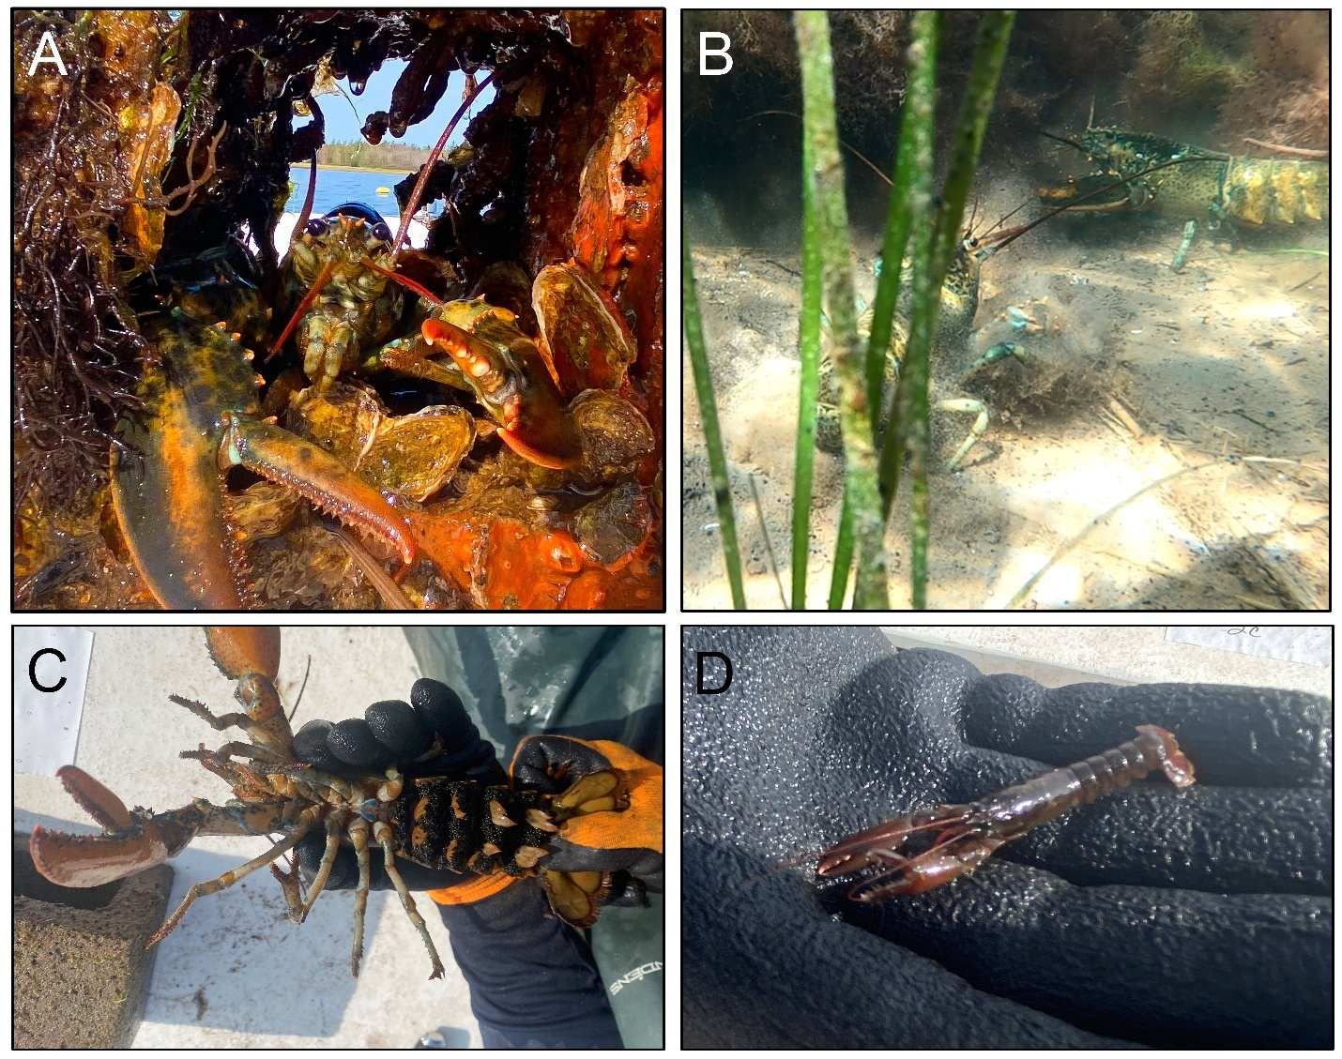
Figure S1. Notable observations of American lobsters (Homarus americanus) engaging with the artificial reefs, including (A) a sheltering lobster amongst some juvenile oysters and other organisms after bringing a concrete block onto the boat, (B) two lobsters fighting over access to a reef, (C) a berried female from one of the reefs, and (D) a juvenile recruit from one of the reefs.
Table S1. Model information for data loggers used to monitor abiotic parameters.
Parameter | Logger model | Link
Dissolved oxygen | Onset HOBO U26-001 dissolved oxygen logger | https://www.onsetcomp.com/products/data-loggers/u26-001?srsltid=AfmBOop_OLGXQ0DIiByQCPk7jHXzF-g6xCtvFpKXLYVDPydL6BX14Ogw
pH | Onset HOBO MX2501 pH and temperature logger | https://www.onsetcomp.com/products/data-loggers/mx2501?srsltid=AfmBOorCBO1OxM2rDKGJZKXs40iV198FoWYw3p6vUACcwyRk5MrStVbr
Temperature | Onset HOBO MX2501 pH and temperature logger | https://www.onsetcomp.com/products/data-loggers/mx2501?srsltid=AfmBOorCBO1OxM2rDKGJZKXs40iV198FoWYw3p6vUACcwyRk5MrStVbr
Turbidity | Observator Analite NEP-595 turbidity logger | https://observator.com/products/nep-595-turbidity-logging-probe/

Table S2. Results of pairwise comparisons between individual reef year classes for taxonomic richness and whole-community biomass. Estimate = model-predicted difference (direction and magnitude) of the first factor level in the contrast relative to the second level in the contrast, reported on the log-scale; SE = standard error; df = degrees of freedom.
Richness
Contrast | Estimate | SE | df | z-ratio | p-value
0 year - 1 year | -0.95 | 0.15 | Inf | -6.57 | <0.0001
0 year - 2 year | -0.93 | 0.15 | Inf | -6.39 | <0.0001
1 year - 2 year | 0.02 | 0.11 | Inf | 0.22 | 0.9742
Biomass
Contrast | Estimate | SE | df | z-ratio | p-value
0 year - 1 year | 0.02 | 0.00 | 24 | 6.65 | <0.0001
0 year - 2 year | 0.03 | 0.00 | 24 | 7.49 | <0.0001
1 year - 2 year | 0.00 | 0.00 | 24 | 6.05 | <0.0001

Table S3. Results of redundancy analysis RDA models for differences in abundance and biomass of whole communities, and sessile benthic animals only, across year classes.
Whole-community biomass
Source of variation | df | Variance | F-value | p-value | Adjusted R²
Model | 2 | 0.43 | 42.16 | <0.0001 | 0.76
Residuals | 24 | 0.12 | - | - | -
Sessile biomass
Source of variation | df | Variance | F-value | p-value | Adjusted R²
Model | 2 | 0.46 | 66.77 | <0.0001 | 0.83
Residuals | 24 | 0.08 | - | - | -
Whole-community abundance
Source of variation | df | Variance | F-value | p-value | Adjusted R²
Model | 2 | 0.07 | 10.81 | <0.0001 | 0.43
Residuals | 24 | 0.08 | - | - | -
Sessile abundance
Source of variation | df | Variance | F-value | p-value | Adjusted R²
Model | 2 | 0.17 | 13.14 | <0.0001 | 0.48
Residuals | 24 | 0.16 | - | - | -

Table S4. Results of RDA pairwise comparisons between individual reef year classes for abundance and biomass of whole communities, and sessile benthic animals only, across year classes. df = degrees of freedom, SS = sum of squares.
Whole-community biomass
Contrast | df | SS | z-ratio | p-value
0 year - 1 year | 1 | 0.31 | 37.30 | <0.0001
0 year - 2 year | 1 | 0.41 | 51.98 | <0.0001
1 year - 2 year | 1 | 0.25 | 36.72 | <0.0001
Sessile biomass
Contrast | df | SS | z-ratio | p-value
0 year – 1 year | 1 | 0.39 | 64.40 | <0.0001
0 year – 2 year | 1 | 0.45 | 94.08 | <0.0001
1 year – 2 year | 1 | 0.22 | 43.43 | <0.0001
Whole-community abundance
Contrast | df | SS | z-ratio | p-value
0 year - 1 year | 1 | 0.06 | 18.13 | <0.0001
0 year - 2 year | 1 | 0.06 | 10.32 | <0.0001
1 year - 2 year | 1 | 0.04 | 6.77 | <0.0001
Sessile abundance
Contrast | df | SS | z-ratio | p-value
0 year - 1 year | 1 | 0.17 | 16.65 | <0.0001
0 year - 2 year | 1 | 0.17 | 23.13 | <0.0001
1 year - 2 year | 1 | 0.05 | 4.22 | <0.0001

Table S5. Results of generalized linear models for the effect of reef year class on the abundance and biomass of oyster spat and adults. LR χ2 = likelihood-ratio chi square test statistic; df = degrees of freedom.
Abundance
Life stage | Source of variation | LR χ² | df | p-value
Spat | Year class | 27.8 | 2 | <0.0001
Adult | Year class | 331.2 | 2 | <0.0001
Biomass
Life stage | Source of variation | LR χ² | df | p-value
Spat | Year class | 28.3 | 2 | <0.0001
Adult | Year class | 5261.7 | 2 | <0.0001

Table S6. Results of pairwise comparisons between individual reef year classes for abundance and biomass of oyster spat and adults. Estimate = model-predicted difference (direction and magnitude) of the first factor level in the contrast relative to the second level in the contrast, reported on the log-scale; SE = standard error; df = degrees of freedom.
Abundance
Life stage | Contrast | Estimate | SE | df | z-ratio | p-value
Spat | 0 year - 1 year | 1.89 | 0.34 | 24 | 5.51 | <0.0001
Spat | 0 year - 2 year | 0.87 | 0.34 | 24 | 2.54 | 0.0459
Spat | 1 year - 2 year | -1.02 | 0.34 | 24 | -2.97 | 0.0175
Adults | 0 year - 1 year | -4.63 | 0.29 | 24 | -16.14 | <0.0001
Adults | 0 year - 2 year | -7.26 | 0.29 | 24 | -25.32 | <0.0001
Adults | 1 year - 2 year | -2.63 | 0.29 | 24 | -9.18 | <0.0001
Biomass
Life stage | Contrast | Estimate | SE | df | z-ratio | p-value
Spat | 0 year - 1 year | 1.35 | 0.28 | 24 | 4.81 | 0.0002
Spat | 0 year - 2 year | 1.12 | 0.28 | 24 | 3.99 | 0.0015
Spat | 1 year - 2 year | -0.23 | 0.28 | 24 | -0.82 | 0.6937
Adults | 0 year - 1 year | -4.19 | 0.24 | 24 | -17.38 | <0.0001
Adults | 0 year - 2 year | -9.17 | 0.24 | 24 | -38.06 | <0.0001
Adults | 1 year - 2 year | -4.98 | 0.24 | 24 | -20.68 | <0.0001

Table S7. Results of linear models testing for effects of stand, time of day, and Julian date (covariate) on dissolved oxygen, pH, and temperature. df = degrees of freedom, SS = sum of squares, MS = mean squares.
Dissolved oxygen
Source of error | df | SS | MS | F-value | p-value
Stand | 1 | 58.86 | 58.86 | 33.60 | <0.0001
Time of day | 1 | 26.53 | 26.53 | 15.14 | <0.0001
Julian date | 29 | 351.49 | 12.12 | 6.92 | <0.0001
Stand × Time of day | 1 | 47.93 | 47.93 | 27.36 | <0.0001
Stand × Julian date | 29 | 50.08 | 1.73 | 0.99 | 0.4873
Residuals | 1358 | 2378.68 | 1.75 | - | -
pH
Source of error | df | SS | MS | F-value | p-value
Stand | 2 | 2.80 | 1.40 | 123.58 | <0.0001
Time of day | 1 | 0.40 | 0.40 | 34.99 | <0.0001
Julian date | 29 | 9.40 | 0.32 | 28.62 | <0.0001
Stand × Time of day | 2 | 0.49 | 0.25 | 21.84 | <0.0001
Stand × Julian date | 58 | 0.47 | 0.01 | 0.71 | 0.9521
Residuals | 2037 | 23.07 | 0.01 | - | -
Temperature
Source of error | df | SS | MS | F-value | p-value
Stand | 2 | 12.80 | 6.40 | 10.58 | <0.0001
Time of day | 1 | 6.50 | 6.54 | 10.80 | <0.0001
Julian date | 29 | 5269.30 | 181.70 | 300.34 | <0.0001
Stand × Time of day | 2 | 6.50 | 3.24 | 5.36 | 0.0048
Stand × Julian date | 58 | 31.40 | 0.54 | 0.89 | 0.6985
Residuals | 2037 | 1232.30 | 0.61 | - | -

Table S8. Results of the generalized linear mixed model (Gamma distribution) for effects of stand, time of day, and Julian date (covariate) on turbidity. . LR χ2 = likelihood-ratio chi square test statistic, df = degrees of freedom.
Source of error | LR X² | df | p-value
Stand | 863.18 | 2 | <0.0001
Time of day | 13.82 | 1 | 0.0002
Julian date | 466.17 | 17 | <0.0001
Stand × Time of day | 29.07 | 2 | <0.0001
Stand × Julian date | 191.14 | 34 | <0.0001

Table S9. Results of pairwise comparisons between the three stands for each of the four abiotic parameters monitored. Estimate = model-predicted difference (direction and magnitude) of the first factor level in the contrast relative to the second level in the contrast, reported on the log-scale; SE = standard error; df = degrees of freedom. For “z-ratio/t-ratio “ column, z-ratios apply to dissolved oxygen, pH, and temperature (linear models), while t-ratios apply to turbidity (generalized linear mixed model with Gamma distribution).
Dissolved oxygen
Contrast | Estimate | SE | df | z-ratio/t-ratio | p-value
Reef - Inside | - | - | - | - | -
Reef - Outside | - | - | - | - | -
Inside - Outside | 0.31 | 0.07 | 1358 | 4.20 | <0.0001
pH
Contrast | Estimate | SE | df | z-ratio/t-ratio | p-value
Reef - Inside | -0.05 | 0.01 | 2037 | -8.95 | <0.0001
Reef - Outside | -0.10 | 0.01 | 2037 | -16.76 | <0.0001
Inside - Outside | -0.05 | 0.01 | 2037 | -7.81 | <0.0001
Temperature
Contrast | Estimate | SE | df | z-ratio/t-ratio | p-value
Reef - Inside | -0.05 | 0.04 | 2037 | -1.16 | 0.4749
Reef - Outside | -0.22 | 0.04 | 2037 | -5.02 | <0.0001
Inside - Outside | -0.17 | 0.04 | 2037 | -3.86 | <0.0001
Turbidity
Contrast | Estimate | SE | df | z-ratio/t-ratio | p-value
Reef - Inside | -1.92 | 0.11 | 1239 | -17.87 | <0.0001
Reef - Outside | -1.85 | 0.11 | 1239 | -17.16 | <0.0001
Inside - Outside | 0.08 | 0.06 | Inf | 1.29 | 0.0093

Table S10. Results of pairwise comparisons between day and night at each of the three stands for each of the four abiotic parameters monitored. Estimate = model-predicted difference (direction and magnitude) of the first factor level in the contrast relative to the second level in the contrast, reported on the log-scale; SE = standard error; df = degrees of freedom. For “z-ratio/t-ratio “ column, z-ratios apply to dissolved oxygen, pH, and temperature (linear models), while t-ratios apply to turbidity (generalized linear mixed model with Gamma distribution).
Dissolved oxygen
Stand | Contrast | Estimate | SE | df | z-ratio/t-ratio | p-value
Outside | Day - Night | -0.09 | 0.10 | 1358 | -0.92 | <0.0001
Inside | Day - Night | 0.66 | 0.10 | 1358 | 6.47 | <0.0001
Reef | Day - Night | - | - | - | - | -
pH
Stand | Contrast | Estimate | SE | df | z-ratio/t-ratio | p-value
Outside | Day - Night | -0.02 | 0.01 | 2037 | -1.82 | 0.0692
Inside | Day - Night | 0.04 | 0.01 | 2037 | 5.10 | <0.0001
Reef | Day - Night | 0.06 | 0.01 | 2037 | 7.10 | <0.0001
Temperature
Stand | Contrast | Estimate | SE | df | z-ratio/t-ratio | p-value
Outside | Day - Night | -0.04 | 0.06 | 2037 | -0.67 | 0.5006
Inside | Day - Night | 0.22 | 0.06 | 2037 | 3.57 | 0.0004
Reef | Day - Night | 0.18 | 0.06 | 2037 | 3.03 | 0.0025
Turbidity
Stand | Contrast | Estimate | SE | df | z-ratio/t-ratio | p-value
Outside | Day - Night | -0.12 | 0.02 | 1239 | -4.99 | 0.0001
Inside | Day - Night | 0.03 | 0.02 | 1239 | 1.71 | 0.0883
Reef | Day - Night | 0.09 | 0.12 | 1239 | 0.75 | 0.4537

